1. **Morphological operations based on OpenCV using Erosion technique**

**Aim:**

To perform morphological operations on opencv using erosion technique.

**Code:**

import cv2

import numpy as np

import matplotlib.pyplot as plt

image = cv2.imread(r"C:\Users\prith\Documents\CV\cvimage.jpg", cv2.IMREAD_GRAYSCALE)

kernel = np.ones((5, 5), np.uint8)

eroded_image = cv2.erode(image, kernel, iterations=1)

plt.figure(figsize=(10, 5))

plt.subplot(1, 2, 1)

plt.title('Original Image')

plt.imshow(image, cmap='gray')

plt.subplot(1, 2, 2)

plt.title('Eroded Image')

plt.imshow(eroded_image, cmap='gray')

plt.show()

**Input:**

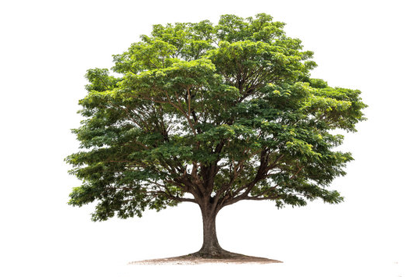

**Output:**

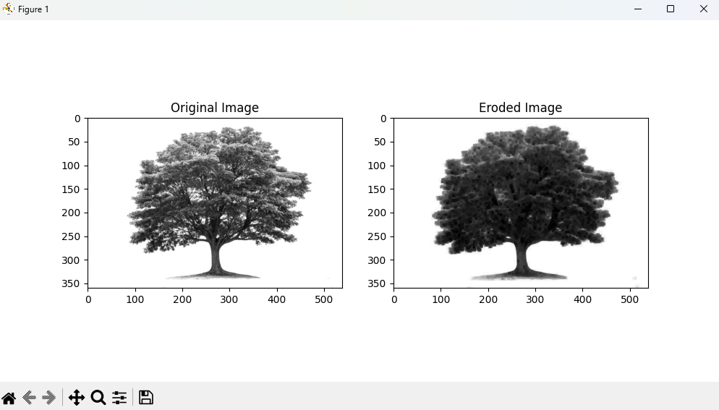

**Result:**

The python code to perform morphological operations on opencv using erosion technique has been executed successfully.